**AMBER**

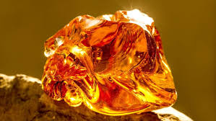 **Name:** Dominican Amber

**Brand:**  Daum

**Model#:** 002

**Color:** Orange

**Price: $100 million**